**NFL DRAFT DATA ANALYZATION(2023)**

Kyle McCullough

University of Wisconsin-River Falls

# **Abstract:**

Data Analysis has continued to shape and change the game of football from how decisions are made on the field and off. This NFL draft data analysis examines the performance of draft picks from 1993 to 2022, with a focus on identifying trends and patterns that may provide insights into the success of future picks, creating a draft pick trade analyzer, and ranking past players, teams, and colleges. The analysis utilizes a variety of statistical methods to explore factors such as draft position, NFL performance, and position-specific metrics to determine which decision a general manager should make in the NFL. The findings suggest that draft position and position-specific metrics can provide valuable information. The analysis provides recommendations for teams to consider when making draft decisions and highlights the potential impact of incorporating data analytics into the scouting process. Overall, this study contributes to the ongoing conversation around the role of data in the NFL and the value of using statistical analysis to inform decision-making in the draft.

# **Highlights:**

* Draft model predicts trading back in NFL draft can often be more valuable.
* Browns have been historically bad at drafting players.
* Miami University has been the best college from 1993 to 2010 at producing NFL talent.

# **1 Introduction:**

*1.1 Introduction to Draft*

On February 8, 1936, at Philadelphia’s Ritz-Carlton Hotel the first ever NFL Draft was held. There were no formal scouting departments, no agents and no 24-hour sports media coverage. The list of eligible players was compiled from newspaper reports, visits to local colleges by team executives, and recommendations to front-office personnel. From this draft only 24 of the 81 players selected ended up playing in the NFL as most tended to opt out and pursue different careers such as the first overall pick, Jay Berwanger, who was the Heisman winner out of the college of Chicago. He ended up pursuing a career as a foam rubber salesman (operations.nfl.com. (n.d.). Since then, the NFL Draft has had a great amount of change in how teams draft, how the draft is presented and how players are scouted. Today teams have very large scouting departments and managerial teams all designed to assemble the best roster in the NFL.

*1.2 Introduction to Data Analysis*  
 Data analysis is the process of examining and interpreting large sets of data to derive useful insights and make informed decisions. It involves using a variety of tools and techniques to organize, clean, and process raw data into meaningful information that can be used to solve problems or identify opportunities. Data analysis is widely used in various industries, and it plays a critical role in helping organizations make informed decisions by providing insights into past trends, current situations, and potential future outcomes. Data analysis is now becoming a large cornerstone in football as many franchises use it as a way of scouting, drafting, and organizing contracts. As the amount of data generated by the NFL continues to grow exponentially, the importance of data analysis is becoming increasingly significant, and its applications are becoming more diverse and innovative. Throughout this research, all of the draft data processing and analyzation were done through R, a statistical and data analysis-based programming language.

# **2 Introduction to Data**

*2.1 NFL Draft Data*

The dataset for this research was supplied by Pro Football Reference. The dataset includes the following:

* **Rnd**-- Round selected in draft  
  Supplemental draft round indicated with 'S'
* **Pick**-- Overall Selection in Draft
* **Tm** – Team that drafted player
* **Player** – Player’s name
* **Pos** -- Position
* **Age** -- Age as of September 1 of the draft year
* **To** -- Last Year
* **AP1** -- First-team all-pro selections
* **PB** -- Pro Bowl Selections
* **St** -- Number of years as primary starter for his team at his position
* **wAV** -- Weighted Career Approximate Value
* **DrAV** -- AV accumulated for team that drafted this player
* **G** -- Games played
* **Cmp** -- Passes completed
* **PassAtt** -- Passes attempted
* **PassYds** -- Yards Gained by Passing
* **PassTD** -- Passing Touchdowns
* **Int(O)** -- Interceptions thrown
* **RushAtt** -- Rushing Attempts (sacks not included in NFL)
* **RushYds** -- Rushing Yards Gained (sack yardage is not included by NFL)
* **RushTD** -- Rushing Touchdowns
* **Rec** -- Receptions
* **RecYds** -- Receiving Yards
* **RecTD** -- Receiving Touchdowns
* **Solo** – Tackles (Before 1994: unofficial and inconsistently recorded from team to team. For amusement only. 1994-now: unofficial but consistently recorded.)
* **Int(D)** -- Passes intercepted on defense
* **Sk** -- Sacks (official since 1982,  
  based on play-by-play, game film  
  and other research since 1960)
* **College/University** – College or University Player attended prior to being drafted to NFL

*2.2 wAV explanation*

One key aspect from the Pro Football Reference dataset that is used in a majority of the research is wAV, other known as weighted career approximate value. This feature generated by Pro Football reference is an attempt at putting an accurate depiction of how successful a career a player has had. Basically, it is a measure of production throughout a player’s career. How wAV is measured is 100% of the player’s best season, 95% of the player’s next best season, 90% of the player’s next best season and so on going down by 5% for each season. The reason for having the 5% decreasing system for wAV is because there has to be a way of balancing peak production against raw career totals. For example, take player A that has 4 years total in the NFL and was spectacular during those 4 years and ends with a total sum of 60 AV for those 4 years. Then you have player B who played 20 years in the NFL and was not great during those 20 years, but in the end his total sum career AV is 62. Does this make Player B better than Player A? The obvious answer is no because excellent short production is better than poor long production. This is why this weighted system is implemented. To measure the production of each individual season for a player Pro Football Reference has an AV, short for Approximate Value, which is an attempt to put a single number on the seasonal value of a player at any position from any year. The founder of Pro Football Reference and also the creator of Approximate Value, Doug Drinen, described AV as:

"AV is not meant to be a be-all end-all metric. Football stat lines just do not come close to capturing all the contributions of a player the way they do in baseball and basketball. If one player is a 16 and another is a 14, we can't be very confident that the 16AV player actually had a better season than the 14AV player. But I am pretty confident that the collection of all players with 16AV played better, as an entire group, than the collection of all players with 14AV."

"Essentially, AV is a substitute for --- and a significant improvement upon, in my opinion --- metrics like 'number of seasons as a starter' or 'number of times making the pro bowl' or the like. You should think of it as being essentially like those two metrics, but with interpolation in between. That is, 'number of seasons as a starter' is a reasonable starting point if you're trying to measure, say, how good a particular draft class is, or what kind of player you can expect to get with the #13 pick in the draft. But obviously some starters are better than others. Starters on good teams are, as a group, better than starters on bad teams. Starting WRs who had lots of receiving yards are, as a group, better than starting WRs who did not have many receiving yards. Starters who made the pro bowl are, as a group, better than starters who didn't, and so on. And non-starters aren't worthless, so they get some points too."

2.3 wAV methodology

The full methodology behind Approximate Value is as follows per Pro Football Reference:

# **2.3.1 Offense**

Every team gets this many points to divvy up among its offensive players:

* **team_offense_points** = 100 * (team offensive points per drive) / (league average offensive points per drive),
* **offensive points per drive** = (7*(rushTD+passTD) + 3*FG) / (rushTD + passTD + turnovers + punts + FGA)

## **2.3.1.1 Offensive line**

As a unit, the offensive line for a given team will share this many points:

* **team_points_for_o_line** = 5 / 11 * team_offense_points

For each offensive lineman (and fullback and tight end), we define:

* **individual_points** = [(games played) + 5*(games started)*(pos_multiplier)] * (all_pro_multiplier),

where **pos_multiplier** = 1.2 for tackles, 1.0 for guards and centers, 0.3 for fullbacks, and 0.2 for tight ends,

and **all_pro_multiplier** = 1.9 for first-team AP all-pro, 1.6 for second-team AP all-pro, and 1.3 for a pro bowler who was not first- or second-team all-pro. [NOTE: all_pro_multiplier is for tackles, guards, and centers only, not fullbacks or tight ends.]

Finally, each individual player receives this many points:

* **approx_value** = (individual_points) / (sum of individual_points for all players on team) * (team_points_for_o_line)

## **2.3.1.2 Skill-position players**

Since we know the entire offensive unit will get team_offense_points, and we gave team_points_for_o_line of those to the line, we have:

* **team_points_for_skill_positions** = team_offense_points - team_points_for_o_line

Now we split that up into two pieces:

* **team_points_for_rushers** = team_points_for_skill_positions * (.22) * [(team_rsh_yards / team_total_yards ) / .37 ]

Now every individual player gets the following share:

* **approx_value** = (rushing yards) / (team rushing yards) * team_points_for_rushers

Finally, we give a small bonus (or impose a small penalty) to running backs who had 200 or more carries and whose yards per carry average was much higher or lower than the league average:

* **bonus** = .75 * [(yards per rush) - (league yards per rush by RBs)], if the player's yards per rush is better than league average.
* **penalty** = 2 * [(yards per rush) - (league yards per rush by RBs)], if the player's yards per rush is worse than league average.

Note that quarterbacks, wide receivers, and anyone else who compiles rushing yards is eligible to get approximate value points at this stage.

Now onto the passers and receivers....

* **team_points_for_passers** = (team_points_for_skill_positions - team_points_for_rushers) * .26

So that leaves:

* **team_points_for_receivers** = (team_points_for_skill_positions - team_points_for_rushers) * .74

Anyone who had a receiving yard gets this many AV points:

* **approx_value** = (receiving yards) / (team receiving yards) * team_points_for_receivers

And similarly for passers.

* **approx_value** = (passing yards) / (team passing yards) * team_points_for_passers

And, as with rushers, we add an efficiency adjustment here:

* **bonus** = .5 * [([Adjusted yards per attempt](http://www.pro-football-reference.com/about/glossary.htm#ay/a)) - (League average adjusted yards per attempt)], if the player's AYPA was better than league average.
* **penalty** = 2 * [(Adjusted yards per attempt) - (League average adjusted yards per attempt)], if the player's AYPA was worse than league average.

# **2.3.2 Defense**

* **team_defense_points** = 100 * [ (1 + 2*M - M2) / (2*M) ],

where M = (team defensive points allowed per drive) / (league average defensive points allowed per drive)

* **team_points_for_front_7** = (2/3) * team_defense_points
* **team_points_for_secondary** = (1/3) * team_defense_points

Now, for all defensive players, we compute:

* **individual_points** = [(games played) + 5*(games started) + sacks + 4*(fumble recoveries) + 4*(interceptions) + 5*(defensive TDs) + (tkl_constant)*(tackles)] + (all_pro_bonus),

where

* **tkl_constant** = 0 if the year is before 1994, and otherwise, tkl_constant = .6 if the player is a defensive lineman, .3 if the player is a linebacker, and 0 of the player is a defensive back.
* **all_pro_bonus** = (all_pro_level)*(year_multiplier),

where

* **all_pro_level** = 1.5 for first-team all-pro, 1.0 for second-team all-pro, and 0.5 for pro bowler
* **year_multiplier** = (year_constant) * (number_of_games_multiplier),

where

* **year_constant** = 40 for the pre-official sack years (1960--1981) and 80 for the post-sack years (1982-present), and  
  number_of_games_multiplier = (number of games played by each team in that season) / 16

Now, each front-seven player gets:

* **approx_value** = [ (individual_points) / (sum of individual_points for all front-seven players on the team) ] * team_points_for_front_7

and each defensive back gets:

* **approx_value** = [ (individual_points) / (sum of individual_points for all defensive backs on the team) ] * team_points_for_secondary

# **2.3.3 Special Teams**

## **2.3.3.1 Returns**

Every player gets one point of approx_value for each kick or punt return TD.

## **2.3.3.2 Kickers**

At the moment, Kicking AV is based solely on field goal & extra point performance. The core stat that determines a kicker's performance is Kicking Points Above Average (PAA), which is derived by comparing a player's XP% and his FG% at various distances (0-19 yds, 20-29 yds, 30-39 yds, 40-49 yds, 50+ yds) to the league average in the same category, to determine the number of points he added above what a league-average kicker would produce in the same number of chances.

* **PAA_total** = PAA_xp + PAA_fg1 + PAA_fg2 + PAA_fg3 + PAA_fg4 + PAA_fg5 + PAA_fg_u

where

* **PAA_xp** = xpm - xpa * lg_xp_pct
* **PAA_fg1** = 3 * (fgm1 - fga1 * lg_fg1_pct)
* **PAA_fg2** = 3 * (fgm2 - fga2 * lg_fg2_pct)
* **PAA_fg3** = 3 * (fgm3 - fga3 * lg_fg3_pct)
* **PAA_fg4** = 3 * (fgm4 - fga4 * lg_fg4_pct)
* **PAA_fg5** = 3 * (fgm5 - fga5 * lg_fg5_pct)
* **PAA_fg_u** = 3 * (fgm_u - fga_u * lg_fg_pct)

where fgm_u and fga_u are field goals made and attempted that are unaccounted for by the distance categories. We have complete distance data going back to 1969; from 1960-1968 we have partial distances for some players. In the case of PAA from unaccounted field goals, kickers are compared to the overall league-average FG%.

From this, we can convert PAA into Approximate Value. First, determine what share of the team's "kicking playing time" the player has received:

* **k_playing_time** = xpa + 3 * fga
* **pct_team_playing_time** = k_playing_time / team k_playing_time

Determine the amount of AV the kicker would get in his playing time if he had an average PAA (prorating a league-average 3.125 figure downwards for seasons of fewer than 16 games):

* **avg_AV** = (3.125 / 16) * team_games * pct_team_playing_time

Then adjust up or down based on his PAA_total (dividing by 5 arbitrarily calibrates the results to match the AV scale of kickers):

* **raw_AV** = avg_AV + (PAA_total / 5)

The final step is to prorate this back up to 16 team games for seasons with unusual schedules:

* **approx_value** = 16 * (raw_AV / team_games)

## **2.3.3.3 Punters**

Right now, punting AV is determined using gross punting average and the ability to avoid blocked punts.

Just like with kickers, the first step is determining productivity above/below average. We're using Adjusted Punt Yards, which are gross punt yards with a 13-yard penalty for blocks (the rationale being that the punter is 13 yards behind the LOS when a block occurs, but we don't assess the full 50-yard fumble/turnover penalty -- as described in [The Hidden Game of Football](http://www.amazon.com/exec/obidos/ASIN/0446514144/footbaperspe-20) -- because the team was punting/turning the ball over anyway).

* **adj_punt_ypa** = (punt_yds - 13 * punt_blocked) / (punt + punt_blocked)

Then, for each league-season, compute the league's average adj_punt_ypa using individual punters' (punt + punt_blocked) totals as the weights. Then figure out how many adjusted punt yards the player added above/below the league average:

* **adj_punt_yds_above_avg** = (punt + punt_blocked) * (adj_punt_ypa - lg_adj_punt_ypa)

We then begin to convert adj_punt_yds_above_avg into Approximate Value. Like with kickers, we determine what share of the team's "punting playing time" the player has received:

* **pct_team_playing_time** = (punt + punt_blocked) / (team_punt + team_punt_blocked)]

Then calculate the amount of AV the punter would get in his playing time if he had an average adj_punt_yds_above_avg ( prorating a league-average 2.1875 figure downwards for seasons of fewer than 16 games):

* **avg_AV** = (2.1875 / 16) * team_games * pct_team_playing_time

Then adjust this up or down based on his adj_punt_yds_above_avg (dividing by 200 arbitrarily calibrates the results to match the AV scale of punters):

* **raw_AV** = avg_AV + (adj_punt_yds_above_avg / 200)

The final step is to prorate this back up to 16 team games for seasons with unusual schedules:

* **approx_value** = 16 * (raw_AV / team_games)

(Pro-Football-Reference.com. (2018).)

For better reference on how certain players are scored check out pro-football-reference.com where they have stats, wAV, and AV calculated for every player after 1960 as well as many other cool features.

*2.3 wAV Examples*

To put better meaning to the wAV and AV calculation here are examples of players around each range, so throughout the paper there is something to reference when wAV or AV is mentioned. Please note that this data is from 1993 to 2022, so newer players may not be ranked as high, and players drafted before 1993 will not be included. The leading all time wAV is Tom Brady with a wAV of 184, second is Peyton Manning with a wAV of 176, and third is Drew Brees with a wAV of 167. The average wAV of a Hall of Famer for each position is as follows:

* QB: 118
* RB: 95
* WR: 95
* TE: 66
* G: 99
* C: 100
* T: 91
* DT: 104
* DE: 104
* ILB: 105
* OLB: 105
* DB: 100
* K: 53
* P: 32

A wAV score of around 100 is about what needs to be achieved in order to be considered to be a Hall of Famer regardless of position. Below though is a deep breakdown of the average stats for certain wAV levels by each position with examples of where some players currently rank as of May 2023:

QB:

|  |  |  |  |  |  |
| --- | --- | --- | --- | --- | --- |
| wAV | AP1 | PB | St | Pass Yd | Pass TD |
| > 160 (First Ballot HOF) Ex: Drew Brees, Aaron Rodgers | 3.75 | 13 | 17.25 | 75,142 | 559 |
| 140 – 159 (Potential HOF) Ex: Matt Ryan, Phillip Rivers | 0.5 | 6 | 14.5 | 63,116 | 401 |
| 120 – 139 (Possible HOF) Ex: Eli Manning, Russell Wilson | 0.25 | 6.33 | 13.66 | 53,898 | 364 |
| 100 – 119 (MVP) Ex: Cam Newton, Donovan McNabb | 0.2 | 3.4 | 11.2 | 42,520 | 262 |
| 80 – 99 (Above Average) Ex: Kirk Cousins, Joe Flacco | 0.1 | 2.66 | 9.06 | 33,143 | 200 |
| 60 – 79 (Average) Ex: Ryan Fitzpatrick,  Andrew Luck | 0.09 | 1.72 | 5.91 | 22,344 | 140 |
| 40 – 59 (Below Average)  Ex: Matt Cassel, Blake Bortles | 0 | 0.69 | 4.46 | 16,747 | 97 |
| 20 – 39 (Bad) Ex: Mark Sanchez, Christian Ponder | 0 | .33 | 2.89 | 10,264 | 56 |
| < 20 (Busts) Ex: JaMarcus Russell, Colt McCoy | 0 | 0 | 0.27 | 1,313 | 6 |

RB:

|  |  |  |  |  |  |
| --- | --- | --- | --- | --- | --- |
| wAV | AP1 | PB | St | Rush Yd | Rush TD |
| > 120 (First Ballot HOF) Ex: LaDainian Tomlinson, Marshall Faulk | 3 | 6 | 10.5 | 12,982 | 123 |
| 100 – 119 (HOF) Ex: Edgerrin James, Adrian Peterson | 1.75 | 4.75 | 9.75 | 12,929 | 86 |
| 80 – 99 (Potential HOF) Ex: Jerome Bettis, Frank Gore | 0.57 | 3.86 | 10 | 11,775 | 68 |
| 60 – 79 (Possible HOF) Ex: Marshawn Lynch,  Jamaal Charles | 0.65 | 2.62 | 6.27 | 8,226 | 57 |
| 40 – 59 (Above Average)  Ex: Devonta Freeman, Jonathan Stewart | 0.3 | 1.36 | 4.28 | 5,657 | 44 |
| 20 – 39 (Average) Ex: Chris Carson, C.J. Spiller | 0.05 | .24 | 2.2 | 3,279 | 22 |
| 10 – 19 (Below Average) Ex: Trent Richardson, Jay Ajaji | 0.02 | 0.14 | 0.98 | 1,488 | 10 |
| < 10 (Busts) Ex: Derrius Guice, Kalen Ballage | 0 | 0.01 | 0.15 | 255 | 2 |

WR:

|  |  |  |  |  |  |
| --- | --- | --- | --- | --- | --- |
| wAV | AP1 | PB | St | Rec Yd | Rec TD |
| > 120 (First Ballot HOF) Ex: Randy Moss, Marvin Harrison | 4 | 6.67 | 12.33 | 15,269 | 146 |
| 100 – 119 (HOF) Ex: Isaac Bruce, Reggie Wayne | 1.25 | 5.5 | 12.25 | 14,478 | 79 |
| 80 – 99 (Potential HOF) Ex: Antonio Brown, Chad Johnson | 1.27 | 5.36 | 11 | 12,817 | 78 |
| 60 – 79 (Possible HOF) Ex: Calvin Johnson,  Julien Edelman | 0.47 | 2.44 | 8.59 | 9,262 | 60 |
| 40 – 59 (Above Average)  Ex: Alshon Jeffery, Michael Crabtree | 0.15 | 0.69 | 5.96 | 6,189 | 38 |
| 20 – 39 (Average) Ex: Jacoby Jones, Tavon Austin | 0.05 | .26 | 3.21 | 3,394 | 20 |
| 10 – 19 (Below Average) Ex: Jerome Simpson, Jakeem Grant | 0.02 | 0.05 | 1.17 | 1,644 | 10 |
| < 10 (Busts) Ex: Corey Coleman, Olabisi Johnson | 0.01 | 0.03 | 0.12 | 248 | 1 |

TE:

|  |  |  |  |  |  |
| --- | --- | --- | --- | --- | --- |
| wAV | AP1 | PB | St | Rec Yd | Rec TD |
| > 70 (HOF) Ex: Tony Gonzalez, Rob Gronkowski | 4 | 9.5 | 12.75 | 11,951 | 87 |
| 50 – 69 (Potential HOF) Ex: Jimmy Graham,  Dallas Clark | 0.5 | 2.75 | 10.25 | 7,604 | 65 |
| 30 – 49 (Above Average)  Ex: Martellus Bennett, Ben Watson | 0.16 | 1.95 | 8.16 | 5,381 | 36 |
| 20 – 29 (Average) Ex: Aaron Hernandez, Eric Ebron | 0 | .47 | 5 | 3,069 | 23 |
| 10 – 19 (Below Average) Ex: Tyler Eifert, Jim Kleinsasser | 0 | 0.1 | 3.61 | 1,768 | 13 |
| < 10 (Busts) Ex: Dan Gronkowski, Jake Butt | 0 | 0.01 | 0.74 | 288 | 2 |

OL:

|  |  |  |  |
| --- | --- | --- | --- |
| wAV | AP1 | PB | St |
| > 100 (HOF) Ex: Jahri Evans, Alan Feneca | 3.25 | 8.5 | 12.5 |
| 80 – 99 (Potential HOF) Ex: Joe Thomas, Tyron Smith | 2.5 | 8 | 10 |
| 60 – 79 (Pro Bowler) Ex: TJ Lang, David Decastro | 0.47 | 2.84 | 9.42 |
| 40 – 59 (Above Average) Ex: Ali Marpet,  Kyle Long | 0.06 | 0.53 | 7.36 |
| 20 – 39 (Average)  Ex: Joe Berger, Matt Kalil | 0 | 0.02 | 3.92 |
| 10 – 19 (Below Average) Ex: Jonathan Scott, Ernest Dye | 0 | 0.03 | 1.29 |
| < 10 (Busts) Ex: Jamain Stephens, Joshua Garnett | 0 | 0 | 0.12 |

DT:

|  |  |  |  |  |  |
| --- | --- | --- | --- | --- | --- |
| wAV | AP1 | PB | St | Solo | Sk |
| > 100 (HOF) Ex: Kevin Williams, Aaron Donald | 4.2 | 6.4 | 11.4 | 369 | 73 |
| 80 – 99 (Possible HOF) Ex: Bryant Young, Geno Atkins | 1.2 | 5.5 | 10.67 | 370 | 70 |
| 60 – 79 (Pro Bowler) Ex: Kyle Williams, Gerald McCoy | 0.25 | 2.65 | 9.7 | 293 | 37 |
| 40 – 59 (Above Average) Ex: Derek Wolfe,  Kawann Short | 0.08 | 0.56 | 7.23 | 226 | 24 |
| 20 – 39 (Average)  Ex: B.J. Raji, Kedric Golston | 0.01 | 0.07 | 3.68 | 139 | 14 |
| 10 – 19 (Below Average) Ex: Johnathan Sullivan, Sharrif Floyd | 0 | 0 | 1.32 | 71 | 6 |
| < 10 (Busts) Ex: Reggie McGrew, Ryan Glasgow | 0 | 0 | 0.11 | 15 | 1.22 |

DE:

|  |  |  |  |  |  |
| --- | --- | --- | --- | --- | --- |
| wAV | AP1 | PB | St | Solo | Sk |
| > 100 (HOF) Ex: Jared Allen, J.J. Watt | 3 | 6.14 | 12.86 | 463 | 125 |
| 80 – 99 (Potential HOF) Ex: Dwight Freeney, John Abraham | 2 | 5.14 | 11.14 | 393 | 105 |
| 60 – 79 (Pro Bowler) Ex: Everson Griffin, Ryan Kerrigan | 0.59 | 2.48 | 8.59 | 360 | 83 |
| 40 – 59 (Above Average) Ex: Brian Robinson,  Bruce Irvin | 0.04 | 0.86 | 6.64 | 255 | 49 |
| 20 – 39 (Average)  Ex: Ezekiel Ansah, Aldon Smith | 0.01 | 0.11 | 3.6 | 152 | 26 |
| 10 – 19 (Below Average) Ex: Derrick Harvey, Cassius Marsh | 0 | 0.02 | 1.35 | 77 | 12 |
| < 10 (Busts) Ex: Erik Flowers, Jonathan Woodard | 0 | 0 | 0.08 | 15 | 2 |

LB:

|  |  |  |  |  |  |  |
| --- | --- | --- | --- | --- | --- | --- |
| wAV | AP1 | PB | St | Solo | Sk | Int |
| > 100 (HOF) Ex: DeMarcus Ware, Ray Lewis | 4.38 | 8.75 | 12.13 | 936 | 68 | 15 |
| 80 – 99 (Potential HOF) Ex: Luke Kuechly, Takeo Spikes | 1.5 | 3.69 | 10.56 | 758 | 39 | 13 |
| 60 – 79 (Pro Bowler) Ex: Clay Matthews, Chad Greenway | 0.61 | 2 | 8.89 | 582 | 36 | 8 |
| 40 – 59 (Above Average) Ex: DeMeco Ryans,  Brian Orakpo | 0.18 | 0.77 | 6.77 | 450 | 19 | 6 |
| 20 – 39 (Average)  Ex: Manti Te'o, Ryan Shazier | 0.02 | 0.14 | 3.93 | 266 | 11 | 3 |
| 10 – 19 (Below Average) Ex: Stephen Weatherly, Ben Gedeon | 0 | 0.01 | 1.3 | 132 | 5 | 1 |
| < 10 (Busts) Ex: Reuben Foster, Shaquem Griffin | 0 | 0.01 | 0.09 | 24 | 1 | 0 |

DB:

|  |  |  |  |  |  |  |
| --- | --- | --- | --- | --- | --- | --- |
| wAV | AP1 | PB | St | Solo | Sk | Int |
| > 100 (HOF) Ex: Ed Reed, Patrick Peterson | 3.5 | 8.67 | 13.67 | 809 | 15 | 50 |
| 80 – 99 (Potential HOF) Ex: Troy Polamalu, Richard Sherman | 2.67 | 6.22 | 10.67 | 512 | 6 | 37 |
| 60 – 79 (Pro Bowler) Ex: Antonio Cromartie, Charles Tillman | 0.76 | 2.9 | 10.28 | 591 | 6 | 33 |
| 40 – 59 (Above Average) Ex: Kam Chancellor,  Jason McCourty | 0.35 | 1.31 | 7.21 | 426 | 5 | 20 |
| 20 – 39 (Average)  Ex: Patrick Chung, Sean Taylor | 0.03 | 0.19 | 4.46 | 306 | 3 | 12 |
| 10 – 19 (Below Average) Ex: Mackensie Alexander, Trae Waynes | 0.02 | 0.04 | 1.56 | 158 | 2 | 5 |
| < 10 (Busts) Ex: Damon Arnette, Gareon Conley | 0 | 0.01 | 0.11 | 34 | 0 | 1 |

Table 1 wAV rankings Tables by Position

# **3 Question: How valuable is each pick in the NFL draft?**

*3.1 Method*

To complete this study the wAV from the Pro Football reference dataset was used as a measure of production meaning this study was very dependent on the calculation of wAV as how most of the studies are in this research. To answer this question a model was needed to show the results of the past drafts and how successful each pick ended up being in the NFL. The problem was just fitting the right type of model to be used. To start, the data was first plotted to see how it looked. Then it was considered which type of regression model may best represent the data. It came clear after looking at the data that it had a large amount of low wAV players, so to cut down on that the data for this model is only from 1993 to 2010. 2010 was chosen because a very large majority of the players drafted in the 2010 draft are now retired, so that means most of their careers are over or close to ending meaning their wAV is capped or close to being capped. Whereas players from more recent drafts such as after 2010 still have multiple years ahead of them in their football careers and yet more years to increase their wAV. After making that change then looking at the data it became clear that the regression line was either going to be linear or logarithmic. The linear and logarithmic models were then compared in R using the export_summs function comparing the R squared, AIC, and BIC. The models’ residuals versus fitted were also compared as well. In all measures the logarithmic model was better and also made more sense for the data. The results from the model can be seen below in Figure 1 and Table 2:

Figure 1 Value of Each NFL Pick Chart

|  |  |
| --- | --- |
| Pick | wAV |
| 1 | 79.710258829259 |
| 2 | 70.2706486154282 |
| 3 | 64.7488306189113 |
| 4 | 60.8310384015976 |
| 5 | 57.7921626689812 |
| 6 | 55.3092204050847 |
| 7 | 53.2099226331595 |
| 8 | 51.391428187771 |
| 9 | 49.7874024085717 |
| 10 | 48.3525524551546 |
| 11 | 47.0545727879275 |
| 12 | 45.8696101912581 |
| 13 | 44.7795502702366 |
| 14 | 43.7703124193329 |
| 15 | 42.8307344586416 |
| 16 | 41.9518179739444 |
| 17 | 41.1262028443474 |
| 18 | 40.3477921947451 |
| 19 | 39.6114788857537 |
| 20 | 38.912942241328 |
| 21 | 38.2484944228199 |
| 22 | 37.6149625741009 |
| 23 | 37.0095971859776 |
| 24 | 36.4299999774315 |
| 25 | 35.8740665087115 |
| 26 | 35.33994005641 |
| 27 | 34.8259741982321 |
| 28 | 34.3307022055063 |
| 29 | 33.8528118090691 |
| 30 | 33.391124244815 |
| 31 | 32.9445767364208 |
| 32 | 32.5122077601178 |
| 33 | 32.0931445775879 |
| 34 | 31.6865926305208 |
| 35 | 31.2918264728898 |
| 36 | 30.9081819809185 |
| 37 | 30.5350496306065 |
| 38 | 30.1718686719271 |
| 39 | 29.818122059897 |
| 40 | 29.4733320275014 |
| 41 | 29.1370562053508 |
| 42 | 28.8088842089933 |
| 43 | 28.4884346278376 |
| 44 | 28.1753523602743 |
| 45 | 27.869306248302 |
| 46 | 27.569986972151 |
| 47 | 27.2771051713473 |
| 48 | 26.9903897636049 |
| 49 | 26.7095864370682 |
| 50 | 26.4344562948849 |
| 51 | 26.1647746340079 |
| 52 | 25.9003298425834 |
| 53 | 25.6409224023698 |
| 54 | 25.3863639844055 |
| 55 | 25.1364766276578 |
| 56 | 24.8910919916797 |
| 57 | 24.6500506754142 |
| 58 | 24.4132015952425 |
| 59 | 24.1804014161987 |
| 60 | 23.9515140309884 |
| 61 | 23.7264100820694 |
| 62 | 23.5049665225942 |
| 63 | 23.2870662124804 |
| 64 | 23.0725975462912 |
| 65 | 22.8614541099669 |
| 66 | 22.6535343637614 |
| 67 | 22.4487413490225 |
| 68 | 22.2469824166942 |
| 69 | 22.0481689756381 |
| 70 | 21.8522162590632 |
| 71 | 21.6590431075237 |
| 72 | 21.4685717670919 |
| 73 | 21.2807277014523 |
| 74 | 21.0954394167798 |
| 75 | 20.9126382983719 |
| 76 | 20.7322584581005 |
| 77 | 20.5542365918362 |
| 78 | 20.3785118460704 |
| 79 | 20.2050256930348 |
| 80 | 20.0337218136748 |
| 81 | 19.8645459878925 |
| 82 | 19.6974459915242 |
| 83 | 19.5323714995611 |
| 84 | 19.3692739951667 |
| 85 | 19.2081066840778 |
| 86 | 19.048824414011 |
| 87 | 18.8913835987295 |
| 88 | 18.7357421464477 |
| 89 | 18.5818593922821 |
| 90 | 18.4296960344754 |
| 91 | 18.2792140741452 |
| 92 | 18.1303767583244 |
| 93 | 17.9831485260813 |
| 94 | 17.8374949575207 |
| 95 | 17.6933827254841 |
| 96 | 17.5507795497783 |
| 97 | 17.4096541537759 |
| 98 | 17.2699762232416 |
| 99 | 17.1317163672484 |
| 100 | 16.9948460810583 |
| 101 | 16.8593377108495 |
| 102 | 16.7251644201813 |
| 103 | 16.5923001580952 |
| 104 | 16.4607196287568 |
| 105 | 16.3303982625503 |
| 106 | 16.2013121885432 |
| 107 | 16.0734382082438 |
| 108 | 15.9467537705789 |
| 109 | 15.8212369480255 |
| 110 | 15.6968664138312 |
| 111 | 15.5736214202669 |
| 112 | 15.4514817778531 |
| 113 | 15.3304278355111 |
| 114 | 15.2104404615876 |
| 115 | 15.0915010257079 |
| 116 | 14.9735913814159 |
| 117 | 14.8566938495574 |
| 118 | 14.7407912023721 |
| 119 | 14.6258666482561 |
| 120 | 14.5119038171618 |
| 121 | 14.3988867466042 |
| 122 | 14.2867998682428 |
| 123 | 14.1756279950112 |
| 124 | 14.0653563087676 |
| 125 | 13.9559703484418 |
| 126 | 13.8474559986538 |
| 127 | 13.7397994787828 |
| 128 | 13.6329873324646 |
| 129 | 13.5270064174981 |
| 130 | 13.4218438961403 |
| 131 | 13.317487225775 |
| 132 | 13.2139241499348 |
| 133 | 13.1111426896624 |
| 134 | 13.0091311351959 |
| 135 | 12.9078780379624 |
| 136 | 12.8073722028676 |
| 137 | 12.7076026808678 |
| 138 | 12.6085587618115 |
| 139 | 12.5102299675403 |
| 140 | 12.4126060452366 |
| 141 | 12.3156769610077 |
| 142 | 12.2194328936971 |
| 143 | 12.1238642289133 |
| 144 | 12.0289615532653 |
| 145 | 11.9347156487994 |
| 146 | 11.8411174876257 |
| 147 | 11.7481582267286 |
| 148 | 11.6558292029533 |
| 149 | 11.5641219281608 |
| 150 | 11.4730280845453 |
| 151 | 11.382539520107 |
| 152 | 11.2926482442739 |
| 153 | 11.2033464236683 |
| 154 | 11.1146263780096 |
| 155 | 11.0264805761512 |
| 156 | 10.9389016322438 |
| 157 | 10.851882302022 |
| 158 | 10.7654154792082 |
| 159 | 10.6794941920302 |
| 160 | 10.5941115998482 |
| 161 | 10.5092609898863 |
| 162 | 10.4249357740659 |
| 163 | 10.3411294859361 |
| 164 | 10.2578357776976 |
| 165 | 10.1750484173183 |
| 166 | 10.0927612857345 |
| 167 | 10.0109683741375 |
| 168 | 9.92966378134013 |
| 169 | 9.84884171122229 |
| 170 | 9.76849647025116 |
| 171 | 9.68862246507459 |
| 172 | 9.60921420018443 |
| 173 | 9.53026627564766 |
| 174 | 9.45177338490293 |
| 175 | 9.37373031262013 |
| 176 | 9.29613193262113 |
| 177 | 9.21897320585918 |
| 178 | 9.14224917845547 |
| 179 | 9.06595497979052 |
| 180 | 8.99008582064881 |
| 181 | 8.9146369914148 |
| 182 | 8.83960386031863 |
| 183 | 8.76498187172987 |
| 184 | 8.69076654449783 |
| 185 | 8.61695347033677 |
| 186 | 8.54353831225466 |
| 187 | 8.47051680302413 |
| 188 | 8.39788474369405 |
| 189 | 8.32563800214078 |
| 190 | 8.25377251165746 |
| 191 | 8.18228426958047 |
| 192 | 8.11116933595167 |
| 193 | 8.04042383221543 |
| 194 | 7.97004393994929 |
| 195 | 7.90002589962729 |
| 196 | 7.83036600941497 |
| 197 | 7.76106062399482 |
| 198 | 7.69210615342178 |
| 199 | 7.62349906200734 |
| 200 | 7.55523586723168 |
| 201 | 7.48731313868295 |
| 202 | 7.41972749702285 |
| 203 | 7.35247561297777 |
| 204 | 7.28555420635467 |
| 205 | 7.21896004508112 |
| 206 | 7.15268994426859 |
| 207 | 7.08674076529849 |
| 208 | 7.02110941493017 |
| 209 | 6.95579284443043 |
| 210 | 6.89078804872365 |
| 211 | 6.82609206556223 |
| 212 | 6.76170197471657 |
| 213 | 6.69761489718416 |
| 214 | 6.63382799441715 |
| 215 | 6.57033846756795 |
| 216 | 6.50714355675231 |
| 217 | 6.4442405403295 |
| 218 | 6.38162673419889 |
| 219 | 6.31929949111273 |
| 220 | 6.25725620000464 |
| 221 | 6.19549428533317 |
| 222 | 6.13401120644028 |
| 223 | 6.07280445692423 |
| 224 | 6.01187156402651 |
| 225 | 5.95121008803233 |
| 226 | 5.89081762168453 |
| 227 | 5.83069178961039 |
| 228 | 5.77083024776096 |
| 229 | 5.71123068286276 |
| 230 | 5.65189081188135 |
| 231 | 5.59280838149662 |
| 232 | 5.53398116758931 |
| 233 | 5.47540697473868 |
| 234 | 5.41708363573081 |
| 235 | 5.35900901107757 |
| 236 | 5.30118098854555 |
| 237 | 5.2435974826952 |
| 238 | 5.1862564344295 |
| 239 | 5.1291558105522 |
| 240 | 5.07229360333519 |
| 241 | 5.01566783009492 |
| 242 | 4.9592765327776 |
| 243 | 4.90311777755297 |
| 244 | 4.84718965441624 |
| 245 | 4.79149027679848 |
| 246 | 4.73601778118464 |
| 247 | 4.68077032673946 |
| 248 | 4.62574609494104 |
| 249 | 4.57094328922152 |
| 250 | 4.5163601346152 |
| 251 | 4.46199487741355 |
| 252 | 4.40784578482715 |
| 253 | 4.35391114465431 |
| 254 | 4.30018926495616 |
| 255 | 4.24667847373819 |

Table 2 Value of Each Draft Pick Table

Sometimes during trades between teams in the NFL, franchises will also trade future picks for certain rounds not knowing what specific pick it would be just knowing the range it will be in. Each round consists of 32 picks for each NFL team, although some picks can be taken away as punishment by the NFL, but most of the time there are 32 picks. So, in order to best represent the value of when teams trade these future round picks a table has been created by taking the average wAV of players prior to 2011 by each round. The results were as followed:

|  |  |
| --- | --- |
| Rnd | averagewAV |
| 1 | 46.357143 |
| 2 | 28.531481 |
| 3 | 18.572165 |
| 4 | 14.588333 |
| 5 | 9.946218 |
| 6 | 7.708978 |
| 7 | 6.597403 |

Table 3 wAV per round table

*3.2 Analysis*

According to the model there is a sharp change in value from the first pick to about the tenth pick where there is about an around an overall 40 wAV change from just of a span of 10 picks after that it seems to level off and slowing decline all the way down to 4 wAV near the end of the draft. One interesting thing the model implicates is that unless a franchise is trading into the top 8 picks or so then there isn’t much need to trade up because the talent seems to mostly level off after about 8 to 10 picks. This would mean that most of the time trading back would be more beneficial than trading up. Although this is what the model and data would implicate there are many things to also consider in this. For example, NFL franchises can only have 53 players on their NFL rosters and 11 on the field at a time, so obviously if a team had 30 seventh round picks that would not be more valuable than 1 first round pick. Although when there is a balanced level of draft capital between teams this could be a good implication of which team is getting the better value. It is also very important too to also look at the prospects that will be around the picks because every draft is different from the other with where positional talent is found. Another thing that stood out from the model is the first overall pick is around 80 wAV which for most positions is almost equal to a borderline Hall of Fame player.

# **4 Question: What teams have had the best and worst drafts historically?**

*4.1 Method*

For this study the data required a bit of processing before analyzation because since 1993 many franchises have relocated and changed abbreviations. For example, the Los Angeles Rams (LAR) is the same franchise as the St. Louis Rams (STL) and the Los Angeles Rams (RAM). The Rams just relocated from Los Angeles to St. Louis in 1995 and then back to Los Angeles in 2016. Other teams that have relocated and changed abbreviations since 1993 were the Phoenix Cardinals (PHO) to the Arizona Cardinals (ARI) in 1994, the Los Angeles Raiders (RAI) to the Oakland Raiders (OAK) in 1995 and then to the Las Vegas Raiders (LVR) in 2020, and the San Diego Chargers (SDG) to the Los Angeles Chargers (LAC) in 2017. After cleaning the data to have every franchise represented once, the wAV for the average player (averagewAV) that each NFL franchise has drafted was calculated and the NFL franchises were compared. The results from the study can be seen below:

|  |  |
| --- | --- |
| Fran | averagewAV |
| PIT | 17.9561752988048 |
| GNB | 17.7977941176471 |
| BAL | 17.528384279476 |
| NOR | 17.4642857142857 |
| SEA | 17.2105263157895 |
| CAR | 16.9716981132075 |
| IND | 16.8786610878661 |
| NWE | 16.6125461254613 |
| HOU | 16.1809045226131 |
| NYG | 16.1644444444444 |
| DAL | 16.1411290322581 |
| PHI | 16.068 |
| ARI | 16.0127659574468 |
| CIN | 15.9372549019608 |
| LAC | 15.8982300884956 |
| ATL | 15.7946428571429 |
| BUF | 15.6285714285714 |
| KAN | 15.625550660793 |
| SFO | 15.476 |
| CHI | 15.4510638297872 |
| NYJ | 15.4330357142857 |
| MIA | 15.4159663865546 |
| TAM | 15.2094017094017 |
| DEN | 15.0983606557377 |
| JAX | 15.0431034482759 |
| LAR | 14.992337164751 |
| MIN | 14.8682170542636 |
| TEN | 14.7227272727273 |
| DET | 14.3039647577093 |
| LVR | 13.7391304347826 |
| WAS | 13.5198237885463 |
| CLE | 13.0044843049327 |

Table 4 Historical Franchise Draft Success Table

Figure 2 Average Drafted Player Value Chart

*4.2 Analysis*

The top 3 franchises with the highest averagewAV were the Steelers, Packers, and Ravens. This makes a lot of sense as from 2000 to 2020 all of these franchises have won a super bowl as well as have a good number of Hall of Fame players come through. The bottom 3 were the Browns, Commanders, and Raiders. This also makes a lot of sense as none of these teams won any super bowls during this era and not only that, but they were also not very good during this era as well. The Browns especially stand out here because until recently they were historically bad for a long period of time in the 2010s.

# **5 Question: Which colleges produce the best NFL athletes?**

*5.1 Method*

For this study all the players from the dataset were at first grouped by the College/University they attended prior to being drafted into the NFL. The college that players were grouped into was their last college played for prior to entering the NFL draft. So, players like Jalen Hurts, a standout quarterback for Alabama and Oklahoma, are grouped with only Oklahoma because that was the last college, he played for prior to entering the draft. After the players were grouped by their colleges the sum of all the players wAV (weighted average value) was calculated and then compared. This obviously will give a good representation of which college produces the most NFL talent, but it doesn’t consider how necessarily good the players were. So, this would be a quantity over quality representation. In order to get a representation of quality the study also compared the average for each player drafted from each college for colleges with at least 20 players drafted from 1993 to 2010. The reasoning for these specific parameters is because currently in the NFL 1,301 of the 1,884 players in the NFL are from Power Five colleges. There are 65 Power Five colleges, so that would equate to about 20 players from each Power Five college (Reubenking, D. (2021)). Then the specific time from 1993 to 2010 is because players drafted after 2010 are still finishing or even starting their career in the NFL, so they won’t have as high of a wAV as those drafted prior to 2010.

|  |  |
| --- | --- |
| College | sumwAV |
| Miami (FL) | 3435 |
| Ohio St. | 3386 |
| Florida St. | 3211 |
| Alabama | 3085 |
| LSU | 3081 |
| Georgia | 3020 |
| USC | 2798 |
| Michigan | 2673 |
| Florida | 2668 |
| Notre Dame | 2352 |
| Tennessee | 2339 |
| California | 2191 |
| Texas | 2078 |
| Penn St. | 2071 |
| Nebraska | 2052 |
| Oklahoma | 1962 |
| Auburn | 1907 |
| Wisconsin | 1794 |
| Texas A&M | 1709 |
| Iowa | 1681 |
| Clemson | 1640 |
| Boston Col. | 1574 |
| North Carolina | 1555 |
| Washington | 1485 |
| Stanford | 1461 |
| Virginia | 1458 |
| Mississippi St. | 1371 |
| UCLA | 1344 |
| North Carolina St. | 1342 |
| Purdue | 1327 |
| Mississippi | 1322 |
| Colorado | 1301 |
| Oregon | 1295 |
| Michigan St. | 1294 |
| South Carolina | 1293 |
| Virginia Tech | 1287 |
| Pittsburgh | 1216 |
| Utah | 1172 |
| Louisville | 1132 |
| Illinois | 1048 |
| Maryland | 1037 |
| Syracuse | 1036 |
| Arizona St. | 1022 |
| West Virginia | 984 |
| Kansas St. | 967 |
| Georgia Tech | 896 |
| Arizona | 870 |
| Arkansas | 863 |
| TCU | 810 |
| Kentucky | 795 |
| Oregon St. | 790 |
| Fresno St. | 769 |
| Oklahoma St. | 756 |
| Missouri | 743 |
| Boise St. | 722 |
| Memphis | 714 |
| San Diego St. | 711 |
| Cincinnati | 706 |
| Central Florida | 694 |
| Washington St. | 602 |
| Texas Tech | 600 |
| Rutgers | 552 |
| BYU | 548 |
| Vanderbilt | 520 |
| Marshall | 499 |
| Temple | 499 |
| Baylor | 498 |
| Houston | 484 |
| Indiana | 454 |
| Northwestern | 446 |
| Louisiana Tech | 434 |
| Wake Forest | 433 |
| Minnesota | 430 |
| Hawaii | 422 |
| Southern Miss | 407 |
| South Florida | 399 |
| Colorado St. | 388 |
| Kansas | 353 |
| Nevada | 352 |
| East Carolina | 348 |
| Iowa St. | 329 |
| Louisiana | 321 |
| Connecticut | 318 |
| Western Michigan | 316 |
| Central Michigan | 309 |
| Northern Illinois | 300 |
| New Mexico | 286 |
| Utah St. | 283 |
| La-Monroe | 262 |
| SMU | 260 |
| Texas-El Paso | 247 |
| Miami (OH) | 246 |
| East. Michigan | 245 |
| Tulane | 244 |
| Troy | 235 |
| Arkansas St. | 228 |
| Toledo | 227 |
| Idaho | 221 |
| Tulsa | 212 |
| Alcorn St. | 209 |
| Akron | 206 |
| Texas A&M-Kingsville | 205 |
| Harvard | 197 |
| Northern Iowa | 194 |
| Duke | 193 |
| Appalachian St. | 190 |
| Ala-Birmingham | 186 |
| North Dakota St. | 185 |
| Western Illinois | 183 |
| Chattanooga | 181 |
| Wyoming | 181 |
| San Jose St. | 179 |
| Northern Colorado | 174 |
| East. Washington | 170 |
| Buffalo | 166 |
| South Carolina St. | 162 |
| Delaware | 159 |
| Rice | 153 |
| Hofstra | 147 |
| Samford | 147 |
| Kent St. | 146 |
| S.F. Austin | 146 |
| William & Mary | 146 |
| Middle Tenn. St. | 141 |
| Montana | 137 |
| Texas Southern | 129 |
| Florida International | 128 |
| Florida Atlantic | 119 |
| Northwestern St. (LA) | 119 |
| South Dakota St. | 119 |
| Ark-Pine Bluff | 118 |
| Grand Valley St. | 118 |
| East. Kentucky | 115 |
| Bloomsburg | 114 |
| Cornell | 114 |
| Jackson St. | 114 |
| Bethune-Cookman | 112 |
| Ball St. | 111 |
| UNLV | 109 |
| Florida A&M | 103 |
| Idaho St. | 102 |
| Sonoma St. | 102 |
| Alabama A&M | 97 |
| Ohio | 97 |
| Hampton | 96 |
| Villanova | 96 |
| Georgia Southern | 90 |
| Howard | 90 |
| Southern Illinois | 81 |
| Bowling Green | 80 |
| Coastal Carolina | 80 |
| New Hampshire | 80 |
| Missouri Southern | 78 |
| West Alabama | 78 |
| Charlotte | 76 |
| Illinois St. | 76 |
| Towson | 76 |
| Abilene Christian | 74 |
| Mount Union | 73 |
| Richmond | 73 |
| Saginaw Valley St. | 71 |
| Itawamba (MS) | 70 |
| Central State (OH) | 68 |
| East. Illinois | 67 |
| Tennessee St. | 67 |
| West Texas A&M | 67 |
| Western Kentucky | 65 |
| Fort Valley St. | 64 |
| Sam Houston St. | 64 |
| Grambling St. | 60 |
| Indiana (PA) | 60 |
| Weber St. | 58 |
| Western Carolina | 58 |
| Augustana (SD) | 56 |
| Pittsburg St. | 56 |
| Alabama St. | 55 |
| North Carolina A&T | 55 |
| Regina | 55 |
| McNeese St. | 54 |
| North Alabama | 54 |
| Nicholls St. | 53 |
| East Tennessee St. | 52 |
| Kutztown (PA) | 52 |
| Tuskegee | 52 |
| Portland St. | 50 |
| Yale | 50 |
| Knoxville | 49 |
| North Dakota | 49 |
| James Madison | 48 |
| Massachusetts | 48 |
| Winston-Salem St. | 47 |
| Navy | 46 |
| Central Missouri St. | 45 |
| Hillsdale | 45 |
| West Chester | 44 |
| Colorado State-Pueblo | 43 |
| Hobart | 43 |
| Texas St. | 43 |
| Columbia | 42 |
| Clarion | 40 |
| Cal Poly-San Luis Obispo | 39 |
| Wisconsin–LaCrosse | 39 |
| Liberty | 38 |
| The Citadel | 38 |
| Michigan Tech | 37 |
| Lehigh | 36 |
| Nebraska-Omaha | 36 |
| Texas-San Antonio | 36 |
| Washburn | 36 |
| Princeton | 35 |
| Slippery Rock | 35 |
| Montana St. | 34 |
| UT Martin | 34 |
| Manitoba | 33 |
| NW Oklahoma St. | 33 |
| SE Missouri St. | 33 |
| Furman | 31 |
| Humboldt St. | 31 |
| Kentucky St. | 31 |
| Lane | 30 |
| Air Force | 29 |
| McGill | 29 |
| Southern Utah | 29 |
| Albany State (GA) | 28 |
| Pacific | 28 |
| Southeastern Louisiana | 28 |
| Missouri Western State | 26 |
| New Mexico St. | 26 |
| Valdosta St. | 26 |
| Bentley College | 25 |
| Delaware St. | 25 |
| Morgan St. | 25 |
| Ottawa (KS) | 25 |
| San Diego | 25 |
| Fordham | 24 |
| Midwestern St. | 24 |
| Mount San Antonio JC | 23 |
| South Dakota | 23 |
| Brown | 22 |
| Gardner-Webb | 22 |
| Mars Hill | 22 |
| Murray St. | 22 |
| St. Paul's | 21 |
| Stillman | 21 |
| Presbyterian | 20 |
| South Alabama | 20 |
| Southern | 20 |
| NW Missouri St. | 19 |
| No college | 19 |
| Central Arkansas | 18 |
| East Central (OK) | 17 |
| Lindenwood | 17 |
| Tennessee Tech | 17 |
| Western Oregon | 17 |
| Bucknell | 16 |
| Eastern Illinois | 16 |
| Ferris St. | 16 |
| Northern Arizona | 16 |
| Lenoir-Rhyne | 15 |
| Sioux Falls | 15 |
| Lousiana-Lafayette | 14 |
| Mississippi Delta CC | 14 |
| Missouri State | 14 |
| Norfolk St. | 14 |
| Butte JC (CA) | 12 |
| Old Dominion | 12 |
| Western Ontario | 12 |
| Williams | 12 |
| Elon | 11 |
| Pennsylvania | 11 |
| Wayne State (NE) | 11 |
| Wheaton | 11 |
| California (PA) | 10 |
| East. New Mexico | 10 |
| North Carolina Central | 10 |
| Wisconsin–Stevens Point | 10 |
| Langston | 9 |
| Missouri Western St. | 9 |
| Wisconsin Whitewater | 9 |
| Dartmouth | 8 |
| Fort Hays St. | 8 |
| Virginia St. | 8 |
| Youngstown St. | 8 |
| Charleston (WV) | 7 |
| Delta St. | 7 |
| Sacramento St. | 7 |
| Saint John's (MN) | 7 |
| Dayton | 6 |
| Lambuth | 6 |
| Maine | 6 |
| Tarleton St. | 6 |
| UC Davis | 6 |
| Wingate | 6 |
| Jacksonville St. | 5 |
| Marist | 5 |
| Virginia Union | 5 |
| Wisconsin–Stout | 5 |
| Ashland | 4 |
| North Texas | 4 |
| Northeastern State | 4 |
| Alabama-Birmingham | 3 |
| California Polytechnic State | 3 |
| Central Oklahoma | 3 |
| Concordia-St.Paul (MN) | 3 |
| Indiana St. | 3 |
| Newberry | 3 |
| Northeastern | 3 |
| St. Augustine's | 3 |
| Chadron St. | 2 |
| Concordia (QB) | 2 |
| Fayetteville St. | 2 |
| Georgia St. | 2 |
| Livingstone | 2 |
| Monmouth | 2 |
| Morehouse | 2 |
| Morris Brown | 2 |
| Texas A&M-Commerce | 2 |
| Tusculum | 2 |
| Western New Mexico | 2 |
| Angelo State (TX) | 1 |
| Drake | 1 |
| Georgia State | 1 |
| Harding | 1 |
| Lamar | 1 |
| Robert Morris | 1 |
| Wagner | 1 |
| Albany (NY) | 0 |
| Albion | 0 |
| Arkansasâ€“Monticello | 0 |
| Army | 0 |
| Austin Peay St. | 0 |
| Bethel (TN) | 0 |
| C.W. Post | 0 |
| Carson-Newman | 0 |
| Central Connecticut St. | 0 |
| Clark Atlanta | 0 |
| Eastern Michigan | 0 |
| Gustavus Adolphus | 0 |
| Howard Payne | 0 |
| Jamestown | 0 |
| Long Beach CC | 0 |
| Ouachita Baptist | 0 |
| Pearl River CC | 0 |
| Prairie View A&M | 0 |
| Rhode Island | 0 |
| Rowan | 0 |
| Sacred Heart | 0 |
| Trinity International | 0 |
| West Georgia | 0 |
| Whitworth | 0 |
| Widener | 0 |
| William Penn | 0 |

Table 5 sumwAV per college Table

|  |  |
| --- | --- |
| College | averagewAV |
| Boston Col. | 30.263158 |
| Miami (FL) | 27.69 |
| Michigan | 26.924051 |
| Mississippi | 26.756757 |
| Texas | 26.322581 |
| Purdue | 26.073171 |
| California | 25.261538 |
| Auburn | 25.245614 |
| Memphis | 24.285714 |
| Oklahoma St. | 24.041667 |
| Georgia | 22.988636 |
| Virginia | 22.842105 |
| LSU | 22.5 |
| Utah | 22.410256 |
| Illinois | 22.294118 |
| Pittsburgh | 22.111111 |
| Florida St. | 21.538462 |
| Maryland | 21 |
| Florida | 20.728261 |
| Syracuse | 20.707317 |
| North Carolina St. | 20.522727 |
| USC | 20.484536 |
| Tennessee | 20.040816 |
| South Carolina | 19.947368 |
| San Diego St. | 19.83871 |
| Louisville | 19.435897 |
| Ohio St. | 19.412844 |
| Nebraska | 19.113636 |
| Georgia Tech | 18.775 |
| Washington | 18.54902 |
| Iowa | 18.490909 |
| Notre Dame | 18.218391 |
| Penn St. | 17.974684 |
| Michigan St. | 17.784314 |
| West Virginia | 17.621622 |
| Rutgers | 17.571429 |
| North Carolina | 17.327869 |
| UCLA | 17.183673 |
| Kansas St. | 17.043478 |
| TCU | 16.758621 |
| Texas A&M | 16.721311 |
| Hawaii | 16.5 |
| Oklahoma | 16.161765 |
| Indiana | 16.15 |
| Arizona | 16.06383 |
| Mississippi St. | 15.780488 |
| Oregon St. | 15.705882 |
| Alabama | 15.597222 |
| Oregon | 15.490909 |
| Fresno St. | 15.428571 |
| Washington St. | 15.363636 |
| Colorado | 15.313433 |
| Texas Tech | 14.965517 |
| Virginia Tech | 14.058824 |
| Missouri | 13.884615 |
| Arizona St. | 13.868852 |
| Clemson | 13.320755 |
| Wake Forest | 13.26087 |
| Arkansas | 13.119048 |
| Wisconsin | 12.969697 |
| Kansas | 12.92 |
| Cincinnati | 12.90625 |
| Kentucky | 12.65625 |
| Colorado St. | 12.347826 |
| Stanford | 12.339623 |
| Southern Miss | 11.791667 |
| Baylor | 11.238095 |
| Northwestern | 11.142857 |
| Minnesota | 11.041667 |
| BYU | 8.972222 |

Table 6 avgwAV per College Table

*5.2 Analysis*

The college with by far the most for sumwAV was the University of Miami Florida with a sum of 3435 wAV. The next four were Ohio St. with 3386, Florida St. with 3211, Alabama with 3085, and LSU with 3081. In the past 30 years this makes sense as these have been some of the best college football schools during that time with Alabama, LSU, and Ohio St. having more current success compared to Florida St. and Miami (FL). Although in the past Florida St. and Miami (FL) were powerhouses, so them being in the top five perfectly makes sense. It would not be surprising if this same study is done in the next 10 years if Alabama, LSU, and Ohio St. climb higher on these rankings because currently these are some of the best teams in college football today.

For the averagewAV of each college athlete drafted to the NFL from each college the top 3 colleges were Boston Col. with 30.26, Miami (FL) 27.69, and Michigan with 26.92. The bottom 3 colleges were BYU with 8.97, Minnesota with 11.04, and Northwestern with 11.14. The top team was kind of surprising at first, but after looking into the data it makes sense why Boston Col. has the top spot for players with successful NFL careers. The reason why they seem to not be as great is recently Boston Col. has not been a very successful college football program, but looking at the data Boston Col. had a lot of great players during the late 1990s and early 2000s. Most of these players are also linemen which tend to usually fly under the radar to the casual eye. Boston Col. has also produced some very well-known players that have had very successful NFL careers, such as Matt Ryan, B.J. Raji, and Matt Hasselbeck. The main reason though why Boston Col. is so high though is because they don’t have a lot of players with very low wAV that busted in the NFL. They only have 14 of their 38 players drafted from 1993 to 2010 with a wAV below 10. The next best college was Miami (FL) which is very impressive considering they also had the highest sumwAV out of all colleges, meaning not only do they produce a lot of NFL talent, but a lot of successful NFL talent. A closer look at the players that Miami produced from 1993 to 2010 it is no surprise either why they stand out so much in the data. Ray Lewis, Warren Sapp, and Edgerrin James, who are all Hall of Famers, are just a couple of the elite players Miami produced during this time. Seeing these big-name players leads to the question of why they were not above Boston Col. in the rankings. That is because 49 of the 100 players drafted from Miami (FL) from 1993 to 2010 had below a 10 wAV which is nearly 50 percent of the players drafted.

# **6 Question: Which was the best draft class?**

*6.1 Method*

The methodology used to solve this question was first just a simple grouping of the data by Draft and then creating a sum of all of the players wAV from that draft. The Draft with the highest sumwAV had the best draft class. During this study it is also important to once again keep in mind that players from more recent drafts (past 2010) are most likely still playing and therefore those classes will have a lower wAV than the older draft classes. The results can be seen below:

|  |  |
| --- | --- |
| Draft | sumwAV |
| 2006 | 5035 |
| 1993 | 4987 |
| 1996 | 4899 |
| 2001 | 4776 |
| 2003 | 4731 |
| 2012 | 4652 |
| 1998 | 4585 |
| 2005 | 4573 |
| 2010 | 4552 |
| 2000 | 4499 |
| 2004 | 4466 |
| 2011 | 4461 |
| 1997 | 4330 |
| 2002 | 4317 |
| 1999 | 4289 |
| 2008 | 4227 |
| 2007 | 4175 |
| 2014 | 4166 |
| 1995 | 4101 |
| 1994 | 4076 |
| 2016 | 3997 |
| 2009 | 3978 |
| 2013 | 3977 |
| 2015 | 3791 |
| 2017 | 3640 |
| 2018 | 3420 |
| 2019 | 2496 |
| 2020 | 1999 |
| 2021 | 1298 |
| 2022 | 611 |

Table 7 sumwAV per Draft Table

*6.2 Analysis*

The top three draft classes were 2006 with 5035 wAV, 1993 with 4987 wAV, and 1996 with 4899 wAV. Some of the top players from the 2006 draft class include Jahri Evans (G) 114 wAV, Haloti Ngata (DT) 100 wAV, and Andrew Whitworth (T) 100 wAV. The 2006 draft class was very deep and that is what primarily contributed to such its high sumwAV. The far worst NFL draft class prior to 2010 would be the 2009 draft class with a sumwAV of 3978. This draft class includes top players such as Alex Mack (C) 86 wAV, LeSean McCoy (RB) 83 wAV, and Clay Matthews (LB) 77 wAV. The difference between the 2006 and 2009 draft classes is whopping a 1057 wAV. This also means players drafted in the 2006 draft on average were around 4 wAV better than players drafted in the 2009 draft. To better put this into perspective 4 wAV difference for a WR would equate to around 500 – 800 receiving yards. With this information it goes to show how crucial it is to consider the strength of draft classes when potentially trading future draft picks. Some of the more recent draft classes that had scores that stood out are the 2012 draft with a sumwAV of 4652, the 2014 draft with a sumwAV of 4166, and the 2016 draft with a sumwAV of 3997. These will be ones to keep an eye on while players are still writing their NFL careers.

# **7 Question: When do positions tend to get drafted?**

*7.1 Method*

To answer this question a look was needed into past drafts to see on average where each position was drafted. This was executed by grouping the data by Pos and taking the average for each position. The highest three positions were T with an average pick of 115, then DE with an average pick 119, and then QB with an average pick of 119. See table below:

|  |  |
| --- | --- |
| **Pos** | **avgDraftPos** |
| T | 115.362 |
| DE | 118.6776 |
| QB | 119.5086 |
| CB | 121.7762 |
| OLB | 122.8052 |
| DB | 124.7419 |
| S | 124.9766 |
| DT | 125.4585 |
| WR | 126.0973 |
| LB | 126.8488 |
| RB | 127.6079 |
| G | 130.3859 |
| ILB | 132.1765 |
| TE | 134.8545 |
| C | 135.1359 |
| DL | 137.5806 |
| OL | 146.7636 |
| FB | 159.1528 |
| P | 168.55 |
| K | 168.6833 |
| LS | 213.75 |

Table 8 Average Draft Spot by Position

Although this doesn’t really show that much because more backups are needed for certain positions, thus more players need to be drafted which could then skew the data. For example, on an NFL roster there are usually only 2 sometimes 3 Quarterbacks on the team while for Cornerbacks there are usually around 7. Therefore, more Cornerbacks are usually drafted then Quarterbacks meaning Cornerbacks can be skewed lower than Cornerbacks because a 6th string corner is going to be drafted far later then your backup quarterback. To solve this problem, it would be best to just take the average of the first drafted player from each position in each draft and then take the find the total average pick. This will then show a better representation of when positions tend to first get drafted, which will give a better idea of how valuable positions are to NFL franchises. The following can be seen in the table below:

|  |  |
| --- | --- |
| **Pos** | **avgPick** |
| QB | 5.266667 |
| DE | 6.9 |
| T | 7.633333 |
| WR | 9.966667 |
| DT | 13.266667 |
| RB | 13.333333 |
| CB | 17.875 |
| LB | 19.1 |
| S | 22 |
| OLB | 24.333333 |
| TE | 25.3 |
| G | 26.4 |
| DB | 26.962963 |
| C | 41.103448 |
| ILB | 46.75 |
| OL | 107.125 |
| FB | 116.86364 |
| K | 123.73077 |
| DL | 132 |
| P | 140.22222 |
| LS | 212.14285 |

Table 9 Average Draft Spot by first drafted Position Table

*7.2 Analysis*

The positions that had the highest average draft pick were QB at 5, DE at 7, and T at 7. Certain positions such as DL, ILB, and OL are lower in the rankings because in the Pro Football Reference database they did not start incorporating these specific positions until after 2010. So, they have a smaller number of players to base off of which could lead to why the position groups are so low. This is also why throughout the research paper these positions are not always incorporated and that’s because they weren’t used until after 2010.

# **8 Question: When is the optimal place to draft a certain position?**

*8.1 Method*

To determine the true optimal position in the draft to select certain positions two approaches were taken. The first approach looked at the wAV for each position over the Pick where each player was selected. This was done for every separate position to determine where the best talent is found in the draft according to the past data from the 1993 draft to the 2010 draft for each pick. The second method looked at the order of when each position was selected in their positional group. This method then allows us to look at the difference between the first offensive tackle taken in a draft compared to the last offensive tackle taken in each draft. This makes the analysis more critical per each position because often some positions such as tight ends or running backs don’t go as early in drafts, so then it makes more sense to look at this chart when determining where the positional value has been in past drafts prior to making a draft decision. The results from these two methods are shown below:

Position: T

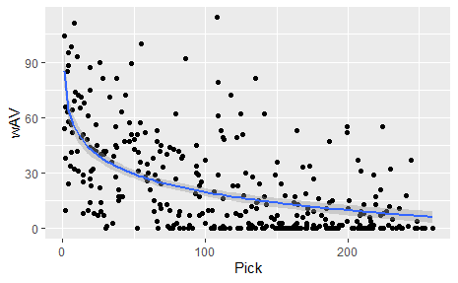

Figure 3 wAV for each Pick for T Chart

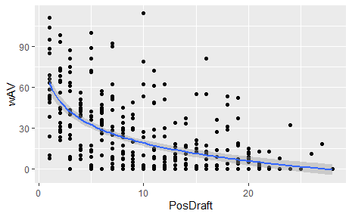

Figure 4 wAV for order of T drafted Chart

Position: QB

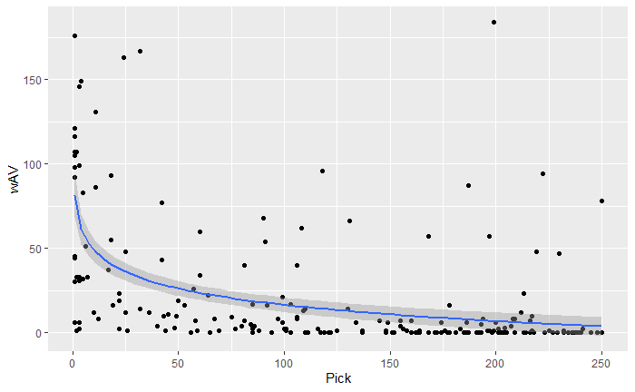

Figure 5 wAV for each Pick for QB Chart

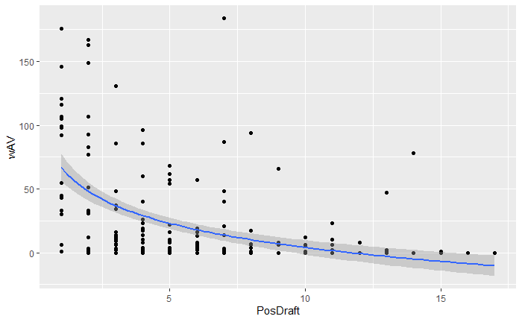

Figure 6 wAV for order of QB drafted Chart

Position: DE

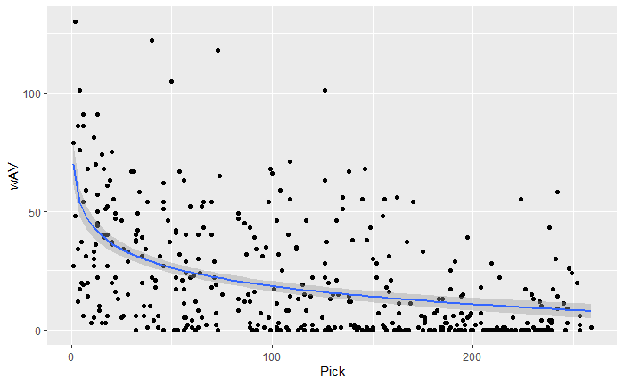

Figure 7 wAV for each Pick for DE Chart

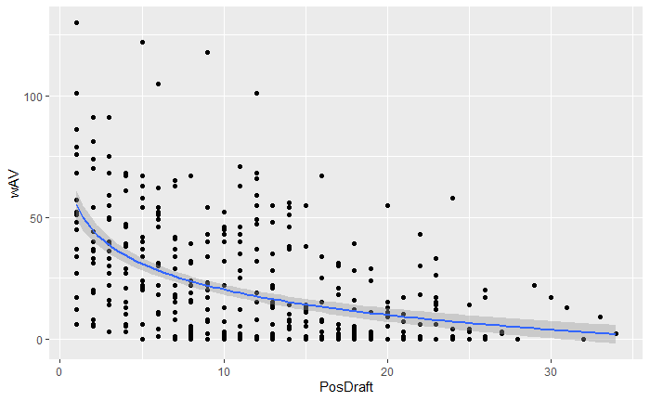

Figure 8 wAV for order of DE drafted Chart

Position: DT

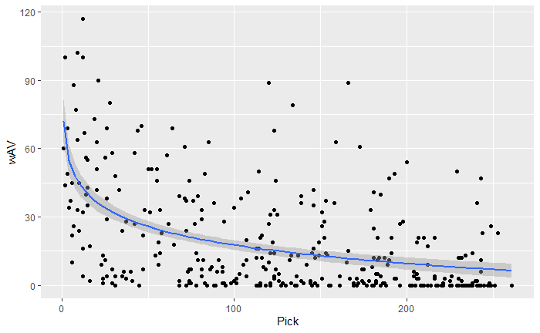

Figure 9 wAV for each Pick for DT Chart

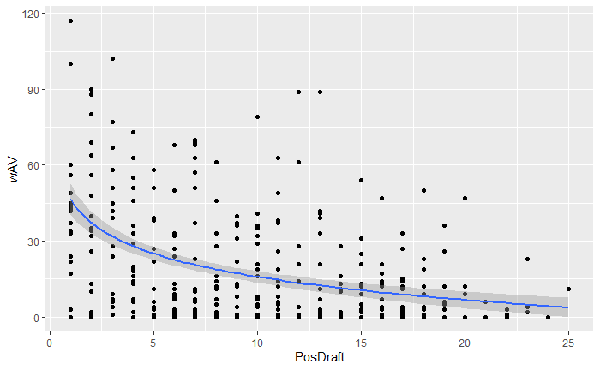

Figure 10 wAV for order of DT drafted Chart

Position: C

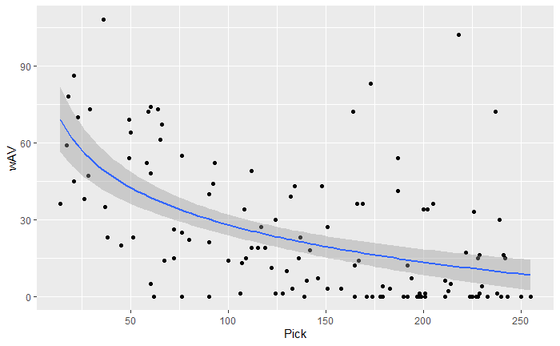

Figure 11 wAV for each Pick for C Chart

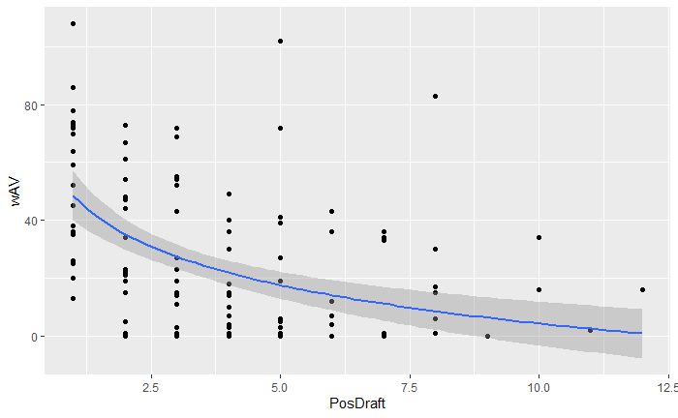

Figure 12 wAV for order of C drafted Chart

Position: G

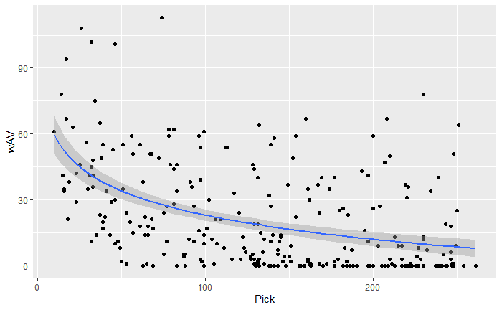

Figure 13 wAV for each Pick for G Chart

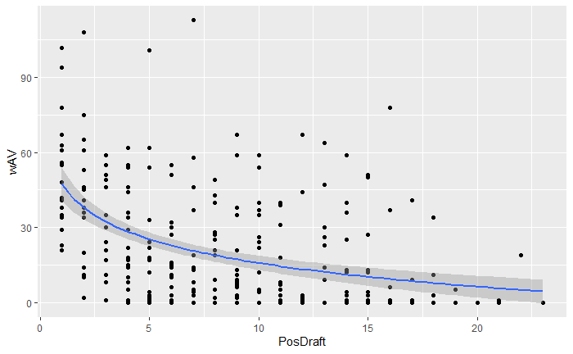

Figure 14 wAV for order of G drafted Chart

Position: LB

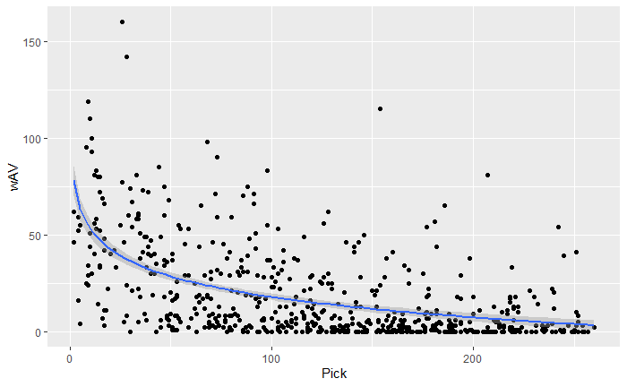

Figure 15 wAV for each Pick for LB Chart

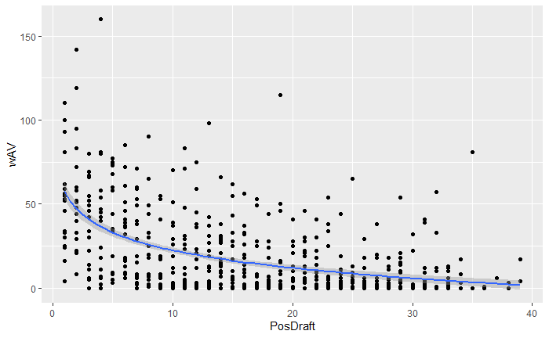

Figure 16 wAV for order of LB drafted Chart

Position: RB

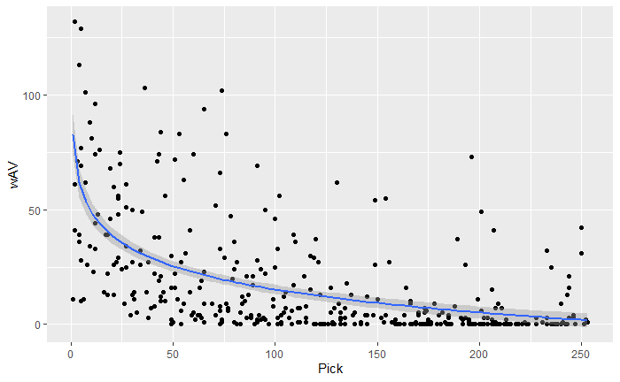

Figure 17 wAV for each Pick for RB Chart

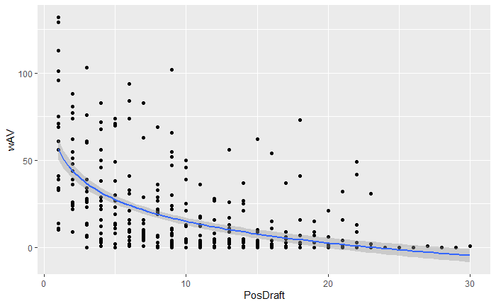

Figure 18 wAV for order of RB drafted Chart

Position: DB

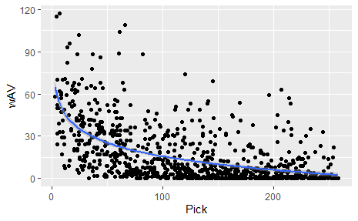

Figure 19 wAV for each Pick for DB Chart

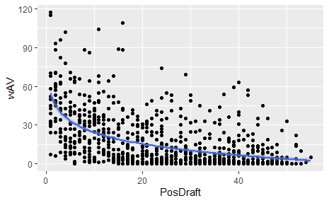

Figure 20 wAV for order of DB drafted Chart

Position: WR

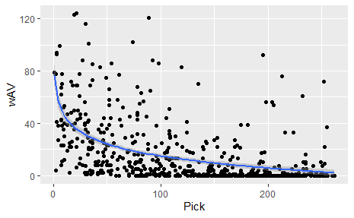

Figure 21 wAV for each Pick for WR Chart

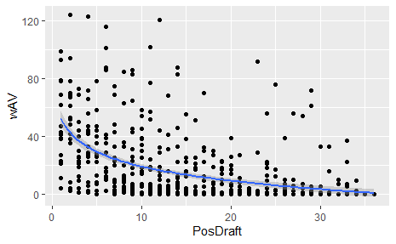

Figure 22 wAV for order of WR drafted Chart

Position: TE

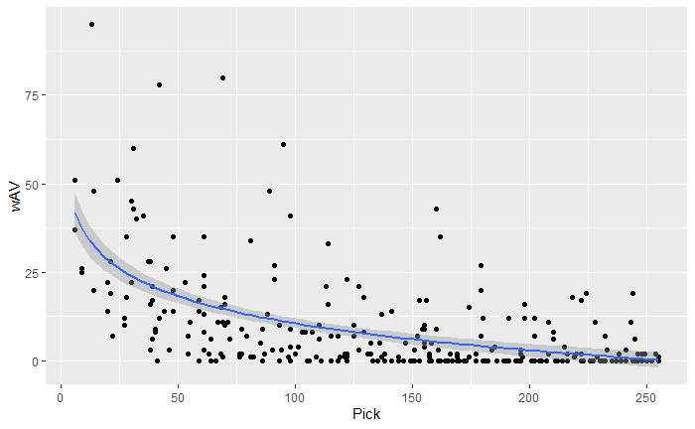

Figure 23 wAV for each Pick for TE Chart

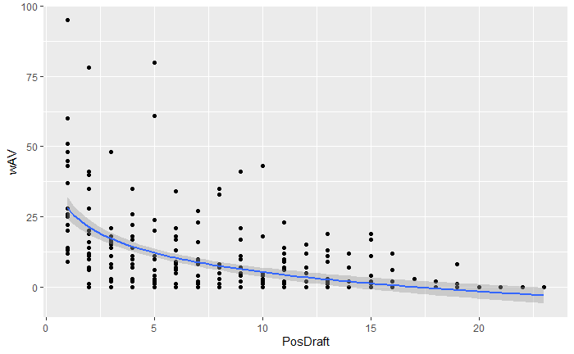

Figure 24 wAV for order of T drafted Chart

*8.2 Analysis*

After going through all the graphs and data it appears to look like the positions that are the most top heavy, meaning that the players at that position that are drafted earlier tend to be a lot better than those drafted later, are WR, RB, T, QB, DT and DE. All the other positions were definitely more normally distributed, meaning more equal across the board. Some things that stood out specifically from this study are how valuable QB’s taken in at the top of the draft are. By far the most significant change from the start of the draft to the end was by the QB’s and the data indicates usually a QB taken after pick 50 is often a bust. Of course, there are a few outliers in the data but the odds of there being an outlier such as Tom Brady are so low. The data almost always indicates that a QB taken in the later rounds will most of the time be a bust and at most an average starter. The top of the draft historically has been where Hall of Fame and All Pro talent at the QB level is found. Another thing that stood out is how evenly distributed TE’s are and how little value they truly are worth. Out of all the positions TE’s seem to be the most even distributed meaning that it would be wiser to draft tight ends later instead of earlier in the draft. This most likely may be due to the fact that they are also the least valuable position besides special team positions. One last thing that was interesting was the difference between RB’s taken early in the draft as opposed to those taken later. In the data there was found to be quite a large difference between career production between running backs drafted in the first round compared to those taken after. The first round running backs had nearly double the average career production compared to running backs taken later. This is interesting, especially with how running backs are viewed in the league today. Today it is considered outlandish to take a running back in the first round because historically that does not equate to team championships, but the data indicates that taking a running back in the early rounds equates to much more production than those taken later. All of this goes to show that production doesn’t always equate to championships especially at the RB position, but usually a highly picked RB will have a very successful NFL career.

# **9 Conclusion:**

All in all, this paper has highlighted the importance of data analysis in the NFL draft process. By examining the performance of draft picks from 1993 to 2022, and using a variety of statistical methods, this analysis has provided valuable insights that can now help to predict success in the NFL, as well as grade draft pick trades, and rank past players, teams, and colleges. Furthermore, the incorporation of data analytics into the scouting process has the potential to revolutionize the way teams make draft decisions, leading to more informed and effective decision-making. As the amount of data generated by the NFL continues to grow, the role of data analysis in the NFL will become increasingly significant, providing teams with the tools they need to succeed in a highly competitive and ever-changing landscape.

**References:**

American Football Wiki. (n.d.). *NFL franchise moves and mergers*. [online] Available at:

[online] https://americanfootball.fandom.com/wiki/NFL_franchise_moves_and_mergers.

Operations.nfl.com. (n.d.). Learn the history of the NFL Draft. | NFL Football Operations. [online]

Available at: <https://operations.nfl.com/journey-to-the-nfl/the-nfl-draft/the-history-of-the->draft/.

Pro-Football-Reference.com. (2018). Pro Football Statistics and History | Pro-Football-Reference.com.

[online] Available at: https://www.pro-football-reference.com/.

Reubenking, D. (2021). *Home - THE TRANSFER PORTAL CFB*. [online] Available at: [online]

https://thetransferportalcfb.com [Accessed 24 Mar. 2023].

‌